The Green Book* and the Men Who Wrote It
*The Training and Care of the Versatile Hunting Dog
By
Patti Carter and Joan von Hardenberg
2/1/12 Copyright © 2012 by the authors

When strangers meet at a NAVHDA event, the conversation invariably turns to their dogs and hunting experiences. Often the training of dogs is mentioned, and this naturally leads to a discussion of the Green Book. This staple of NAVHDA training, written forty years ago, has withstood the test of time and is still in active use today. Neophyte dog handlers are inevitably advised by more experienced dog people to “get the Green Book.”

The authors, Sigbot Winterhelt and Dr. Edward D. Bailey, founders of NAVHDA, come from disparate backgrounds, have different personalities and talents, but are alike in their love for hunting and hunting dogs. They were also united in their vision of establishing an organization dedicated to the versatile hunting breeds. How did they meet and how and why did they join forces to create this training book and initiate what has become NAVHDA?

Sigbot Winterhelt was born in Mainz, Germany in 1926 into a prosperous family. The nickname Bodo came from his mother. Bodo’s father, an architect and avid antique collector, specializing in pewter, was not a hunter or fond of dogs. When asked by his young son for a pet dog, the answer was that dogs were too expensive to own because of the onerous “dog tax” imposed by the German government. Nine-year-old Bodo’s attempt to override that argument was to write a letter to Adolf Hitler requesting an end to the tax. Bodo never received a response. Apparently Hitler had other things on his mind.

Bodo did finally get his first dog four years later. He learned what kind of poems his father liked, memorized them, impressed his parent with his recitations and was granted his request. This first dog was a hunting terrier, a Jagdterrier. However, Bodo’s history with dogs was nearly short-lived after this young dog destroyed one of his father’s favorite antiques, a chair which once belonged to Napoleon Bonaparte.

Although Bodo’s father was not a hunter, his uncle and grandfather were. In fact, his uncle was president of a German hunting dog association. It is worth noting here that the Winterhelt family physician was Dr. Paul Kleeman who was instrumental in developing the prestigious Kleeman Seiger test. The Kleeman Title is one of the most sought after awards for versatile dogs in Germany. Without the knowledge of his father Bodo worked as a helper at hunting dog tests from the age of fourteen. He put signs on trees, carried food and shells, laid tracks, and was a general “go-fer”.

Bodo’s family lost everything during World War II, including his father’s priceless antique collection and their home, which was bombed and burned to the ground, leaving a deep layer of molten pewter in the basement. His older brother, Volkmar, was a lieutenant in the German military. At the end of the war and as the Allies were advancing into Germany, Volkmar swam west across the Elbe River in an attempt to avoid capture by the Red Army. He was taken by the Americans but unfortunately then handed over to the Russians. He spent the next five years in the harsh conditions of a Soviet prisoner of war camp where fewer than half survived (9,000 out of 23,000).

Bodo was conscripted into the army toward the end of the war. He too crossed the Elbe, but via ambulance since he had a severe stomach wound. After capture by American troops he was taken to a British hospital. He was released from the hospital in 1945 into the care of Edmund Löns, a distant neighbor of the Winterhelt family. Herr Löns was a writer and also a very well known breeder and trainer of dogs. He was designated the father of Small Munsterlanders because of his rescue and championship of the breed after World War I. Bodo states, “I learned a lot from Edmund Löns about dogs, breeding, training and handling. Through his help I became the youngest trainer, breeder, handler and judge of German hunting dogs. I also became his son-in-law.”

Germans were not allowed to have guns during the Allied occupation, so any hunting Bodo did during this period was with his dog and a spear. To the best of his knowledge, Bodo was the first German to eventually be given permission to own a shotgun, which he used in his work as a guide and dog trainer.

Bodo’s brother was a dedicated horseman, competing in dressage events after his return from the P.O.W. camp. The two brothers found that post war Europe, with its overpopulation and lack of open space, was not conducive to their passions for dog and horse activities, so they applied for emigration to Canada, finally arriving in 1954. Unfortunately Volkmar later died of cancer, competing in horse events as long as possible.

After his arrival in Canada Bodo worked picking tobacco leaves in southern Ontario and then cutting trees in the depth of winter farther north. On the advice of his brother he relocated to Toronto where he chanced upon a newspaper photo of a veterinarian, Dr. Allen Seecord, pictured with an English Pointer at a hunt trial. Bodo walked miles through ice and snow to locate Dr. Seecord and to ask for a job. The doctor replied, “I have been waiting for you. Start right here.” Bodo never forgot that response. He was hired on the spot and worked for the veterinarian for many years. It was through him that Bodo became manager of the Nicholson Island Club. On this 500 acre island Bodo raised dogs and also thousands of pheasant, chukar, and quail each year. It was also on the island that his idea for a versatile dog organization germinated. He and his growing family lived there for about ten years, moving finally only because they wished to obtain better educational opportunities for their three children.

Eventually Bodo applied for Canadian citizenship. However at the courthouse for the final swearing-in, he realized that he had to swear allegiance to Queen Elizabeth as head of the British Empire. This he refused to do, saying he had once pledged allegiance to an individual, the leader of Germany, when he was in the Hitler Youth and then in the military, and look at the trouble that had resulted. He would pledge loyalty to the country, but not to a person.

As Bodo left the courthouse, still not a citizen of his chosen country, he was approached by an attorney who said he would take his case. Bodo responded that he had no resources to pay a lawyer, but was told that was unnecessary. The attorney would work pro bono because he liked Bodo’s position. Two years later the law had changed and Bodo became a Canadian citizen. He lived there for twenty-two years before moving to the United States. He now has dual citizenship.

Edward Bailey was born in 1931, growing up in Hamburg, Pennsylvania, just north of Pennsylvania Dutch country. His grandmother raised smooth coated Fox Terriers, and at age two Ed was given one. It was the first of many dogs in his life.

While no one in Ed’s immediate family hunted, he did have a great uncle who exposed him to grouse hunting at a very young age. This uncle, who was a retired railroad locomotive engineer, always carried a shotgun in his car during grouse season. When Ed was four or five years old, he went for a car ride with this relative. “He spotted a grouse beside the road, stopped and told me to be very quiet and follow behind him. I helped him eat the bird that night for supper. The whole thing of stalking and flushing and shooting the bird left a huge impression on me. It has never diminished.”

When Ed was fourteen and finally able to get a hunting license, another uncle, who had Beagles and hunted rabbits, took him on his first real hunt. A year later a man who realized how much Ed loved dogs offered him a pair of English Setters. Ed was able to persuade his parents to agree and thus began his life long association with hunting dogs.

Every day after school the teen-age Ed would leash his dogs, cross a Schuylkill River bridge, and walk down a gravel road to an abandoned farm where he could usually find a few pheasants. There he worked his dogs. Today the land that once was that farm is a Cabela’s parking lot. On the farmland Ed eventually met an English Pointer owner who introduced him to the field trial world. Soon other people asked him to help with their dogs; his string of dogs crossing the bridge increased, and he was handling several different breeds, including a German Shorthair.

Ed decided he wanted to be a veterinarian. After graduating from high school he got a job and saved enough for two years of school. He applied for admission to a pre-vet school and received his acceptance letter and a draft notice from the U.S. Army on the same day. It was 1952 and the Korean conflict was in full swing.

Ed declares the army was good to him, and while in the military he worked with research teams in the desert of Arizona. These two years in the service of his country were the only days he did not have a dog in his life. During this time he met people from many different universities and decided he would like to pursue studies in wild animal research after his military duties ended.

Taking advantage of the G.I. Bill, he attended the University of Montana for his undergraduate degree, maintaining a B+ or better average in order to remain eligible for tuition and fee waivers. His graduate degree, a Master’s in Wildlife, also from the University of Montana, resulted from a fellowship grant from the Cooperative Wildlife Research Unit. This grant was partially funded by the Pittman/Robertson Bill which helps support research performed in land grant universities. Ed’s graduate studies involved mule deer and marked the beginning of his focus on animal behavior.

Ed was awarded a scholarship to study under John Paul Scott in a dog research project in Bar Harbor, Maine, but there was no PhD program associated with this work. Dr. Scott steered Ed toward Dr. David Davis in the Zoology Department at Penn State. Ed was accepted into the doctorate program there with the stipulation that his thesis would be on woodchucks, since that was where the grant money was concentrated. A Google search today will label Dr. Bailey as “the groundhog expert.” Ed completed his Doctorate in Zoology at Penn State in 1963 with a specialty in Animal Behavior.

During his educational efforts in Montana and Pennsylvania, Ed was accompanied by his Springer Spaniel, Bo. Bo traveled with him again back to Montana for Ed’s first year of employment after earning his PhD. When Bo died, Ed got his first Griffon. Soon after, he was offered a position at Guelph University in Ontario, Canada to start a program in Animal Behavior within the Zoology Department.

Meanwhile Bodo had come to realize there were no hunting dog organizations or tests in North America similar to those he had left behind in Germany. He decided to see if he could change that situation.

After observing North American field trials extensively, he decided to compete. In Germany he had grown up with and worked with Munsterlanders since Herr Lons had been active in improving that breed. However, distemper had decimated the Munsterlander population in the early 1950’s, and the Pudelpointer replaced them in his activities. In Canada he decided to stick with Pudelpointers and was the first to get permission from the German Pudelpointer Club to bring the breed to North America. He imported Cati v. Waldhof in 1956 and began to win prizes and gain respect from the other competitors. People started to listen to his ideas.

While managing the Nicholson Island Club, Bodo became friends with Douglas Hume, an intelligent, experienced hunter who loved hunting dogs. The two men worked together to adapt the written rules of the German tests into the English language. Bodo would talk to Doug, telling him what he wanted to say and Doug would put it into perfect English. In this way the Pudelpointer Breed Club was established, and the basic ideas of NAVHDA achieved written form. Bodo states emphatically that without Doug Hume he could not have started NAVHDA.

It took longer than he had anticipated to get a small group together with the enthusiasm and understanding to go along with his plans. The first versatile rules were established in 1960 with an organization named the All Purpose Gun Dog Association. In 1961 this group held its first and only trial. It was advertised as an “All Purpose Gun Dog Competition” and attracted fourteen entries. Bodo’s dog, Winterhelle’s Komet, off-spring of Cati, impressed observers with his performance. He won the event (see photo) and was acclaimed by the press. Bodo believes Komet did more to promote versatile principles than any other dog, laying the ground work for NAVHDA.

Although the All Purpose Gun Dog Association did not continue as a viable club, the trial was a demonstration of what dogs were capable of doing. Bodo and Doug finally were able to convince the dog world that these dogs should be considered not all purpose dogs but versatile hunting dogs. Also the idea of tests versus competitive trials was introduced. It was a pivotal point in the conceptual development of NAVHDA.

When Ed Bailey arrived in Ontario in 1964 with his Griffons, he was familiar with the history of the German tests and obtained a copy of the rules which had been translated from German to English by Bodo and Doug Hume. By this time Bodo had established himself as a professional dog trainer and handler. He was also manager of the exclusive private hunting preserve on Nicholson Island on Ontario Lake. In 1965 Ed contacted Bodo, and soon after, an initial hunting dog test was set up on the grounds of the Goodwood Hunt Club where the two men judged along with Jerry Knap. They found they could work well together. This demonstration test attracted a good number of people and kindled interest.

A small group got together and set out a purpose and long term direction. Early efforts were slow, emphasizing quality of results and strong membership, not wanting to push too hard and grow too fast. The goal was not to establish a large competitive organization like the American Kennel Club. While the American culture tends to be competitive, Bodo and Ed felt there could be a place for the non-competitive hunter, an association that emphasized education, co-operative training and conservation.

The dog/hunter alliance is one of the oldest teams in human history. It developed an attitude of fair sportsmanship between hunter and prey with the goal of no suffering or slow death for crippled animals. Bodo quoted the ancient Greek writer Xenephon who wrote in 400 B.C: “Through the understanding of a dog, man exists.” Modern hunters are throwbacks to that old tradition. Although some people have lost the hunting inclination, this new organization would have the responsibility of promoting hunting as an ethical and humane activity that respects all life. Its purpose would be to foster, improve, promote and protect the versatile hunting breeds in North America.

They began to have tests in both Canada and the United States, primarily organized by chapters of the various breed clubs. The early tests were not NAVHDA sanctioned, since it was not yet firmly organized and did not even have a name. Tests were held in California, Virginia, Ontario and Maine.

The test sponsored by the Griffon club in California was one of the largest. It had thirty dogs entered and included many versatile breeds. There were Wirehairs, Pudelpointers, Shorthairs, Vizslas, Weimaraners, and Brittany Spaniels as well as Griffons. No one cared that the tests weren’t sanctioned by anyone. It was the first break from the AKC/American Field competitive mentality. Dogs were actually being evaluated against objective hunting standards.

Eventually the organization became more formalized. By 1969 a name was chosen, and the NAVHDA logo was designed by Floyd Shikoski from the D.C. area. Tests were now being held under the NAVHDA auspices. Up to this point, entry fees had covered the cost of birds and insurance but little else. Other expenses had come out of the organizers’ own resources. A source of money was needed if the program was to go forward.

Joan Bailey, Ed’s wife at the time, came up with the idea of a training book as a means of getting funds. In Ed’s words: “It was 1972 at a small get together at our house. We decided the book had to be just that, a training manual without all the anecdotal stuff, no stories, just a no nonsense step by step approach that would take a newcomer from puppy to utility dog. …….. I would write a section, Joan typed it up and sent it to Bodo who okayed things, added comments and sent it back for what rewrite was needed. We published the book locally, had several printed on better paper, numbered, signed by both of us and leather bound. These were auctioned with the highest bid getting No.1, second No. 2 and so on. We paid for the first printing out of pocket, made enough to get most of it paid back and have a second printing, then several more printings. Though it was sold only through NAVHDA and all income went to NAVHDA as it still does, the book became a very popular training manual. Clem Walton, a long time senior judge and a fisheries biologist, told me some years later that it was obvious the book was written by a research scientist because there was not one bit of humor in the whole thing. I was pleased to hear it.”

Humorous or not, the book is a gold mine of information. Affectionally designated the Green Book, its official title is The Training and Care of the Versatile Hunting Dog. In addition to detailed directions for training with ample illustrations, it outlines the general history of the versatile breeds, describes the proper care of dogs in the house and field including first aid, grooming, feeding, and housing, and ends with the twelve golden rules for training and short biographies of the authors.

The book even includes instructions on building a training table. Bodo had had back surgery and increasingly felt the effects of continuously bending over during his training of many dogs, so he designed the training table which has probably saved the backs of many handlers. It turned out to be a serendipitous creation since the table has many other training benefits. Early printings of the book were in spiral form for ease of use while working with your dog; this would still be useful today.

The aim of the book is eminently clear. On page two the writers state plainly: “The main purpose of this book is to present training techniques and to teach how to use these techniques to enable you to have a truly versatile hunting companion.”

These two gentlemen are still active. In June 2002 they presided over a training clinic in Guelph, Ontario sponsored by the Grand River Chapter. This was the last time they appeared together at a NAVHDA event. Bodo lives in Oregon with his female Pudelpointer, White Lie. His Winterhelle Kennel remains prominent in Pudelpointer breeding programs. Bodo has made a near miraculous recovery from a massive stroke he suffered a few years ago. He states that his doctors declare his progress is indeed rare and that he is to be written up in medical journals. At the 2011 annual NAVHDA meeting in Ottawa, Bodo’s phone call was heard by all attendees as he stated, “If I could do it all over again, I would do the same.” That’s a pretty good validation for a man’s life.

Ed is a permanent resident of Canada, a Professor Emeritus of Guelph University, and retains his U.S. citizenship. He writes a monthly dog behavior column for Gun Dog Magazine. Ed’s body of work is extensive; it has significant breadth and depth. A brief survey of the content of his archives of articles (trader.co.nz/versatiledogs) reveals the scope of his topics: how a dog learns, temperament, the wired dog, cooperation and independence, the fearful dog, socialization, separation anxiety, do dogs think. The list goes on and on. This is a man who has been able to make the leap that so many academics cannot — successfully relating theory to practical applications. Ed knows that insight into a dog’s behavior leads to better training techniques and eventually to a more dependable dog in hunting situations. He is the dog world’s “go-to” man when questions arise, and his solutions to problems are clear, sometimes humorous, always right-on.

Ed hunts with friends, both old and new, and describes his 2011 fall trip to Kansas where his German Wirehair, Pepe, had a run-in with a bobcat while searching out stragglers from a covey of quail. “Pepe let out a yelp and leaped up onto the road with a bobcat wrapped over his head. Feet were wrapped around his head at about eye level, and hind feet one on each side around his ribs just behind the shoulders. I don’t know if the cat jumped off or was thrown off but I could see the thing flying head down through the air.” They made a visit to the vet, administered antibiotics and Pepe was hunting the next day with no serious damage. Ed also has Charlie, a Cesky Fousek, who had been left behind in Canada to keep Ed’s wife, Uta, company. Uta Strelive is known for her life-like and artistic bird carvings.

During the interviews with the authors in preparation for this article, each man deferred to the other; Ed emphasizing the value of Bodo’s critiques and contributions, and Bodo protesting that Ed and Joan did most of the work. The Green Book could probably not have been written by either man alone. The charismatic, witty Bodo and the erudite, articulate professor Ed, both with a practical knowledge of the versatile hunting dog, joined forces to produce a work of lasting value.

Just as Bodo and Ed are founders of NAVHDA, the Green Book provides the foundation for NAVHDA. The North American Versatile Hunting Dog Association owes much to the vision and work of these two men. We are in their debt.

NOTE: Ed and Bodo each reviewed and approved this article as it was being written. Some information has been taken from the Green Book which was published in 1973 and from the official NAVHDA test rules booklet published in June 1975. At that time the President of NAVHDA was Mr. Sigbot Winterhelt and the Secretary and Director of Judging was Dr. Edward D. Bailey. We also consulted the Bodo Winterhelt Pudelpointer Organization and the NAVHDA web sites.

Figure 1 - Bodo with Winterhelle’s Komet (1961)

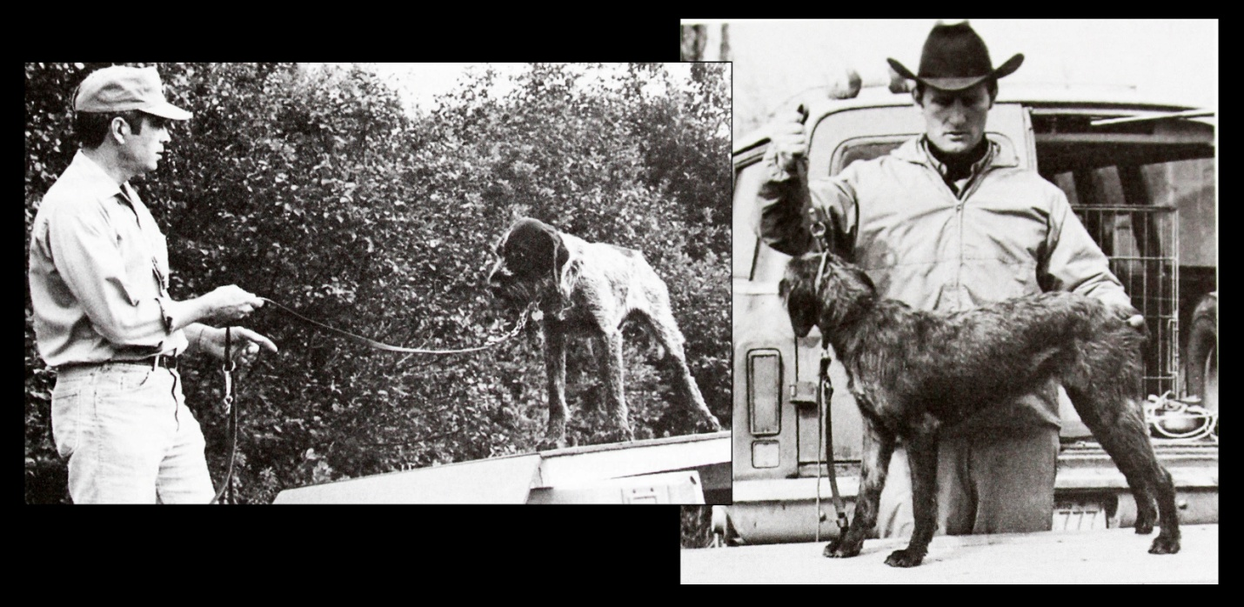
Figure 2 – Ed & Bodo at early Training Clinic

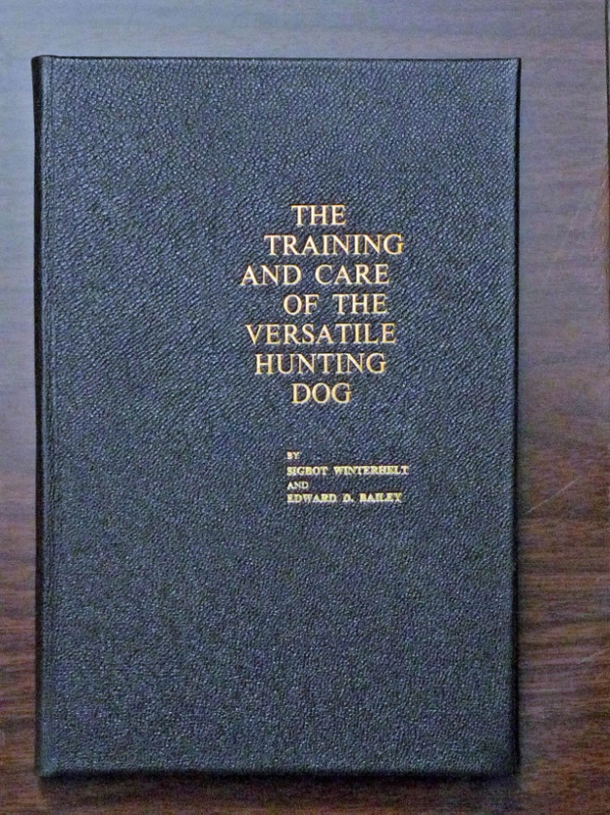
Figure 3 - Leather Bound Training Book

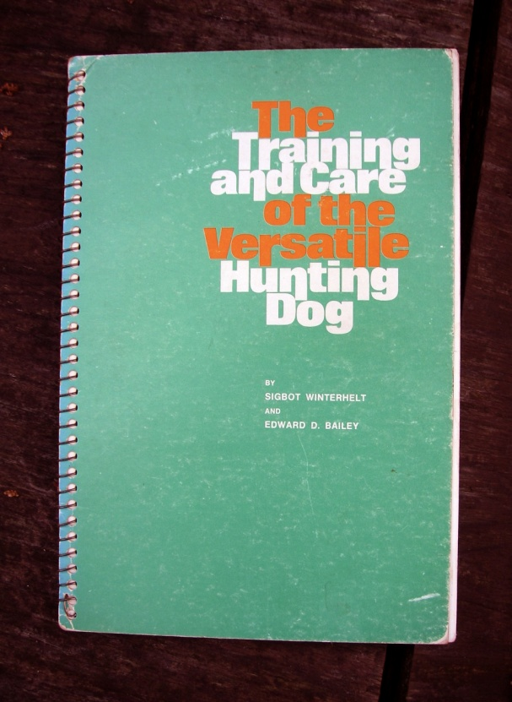
Figure 4 – Spiral Bound Green Book

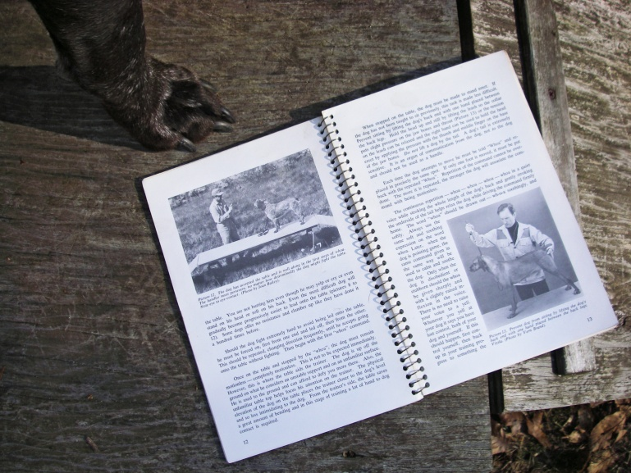
Figure 5 – Spiral Bound Book being used at Training Table

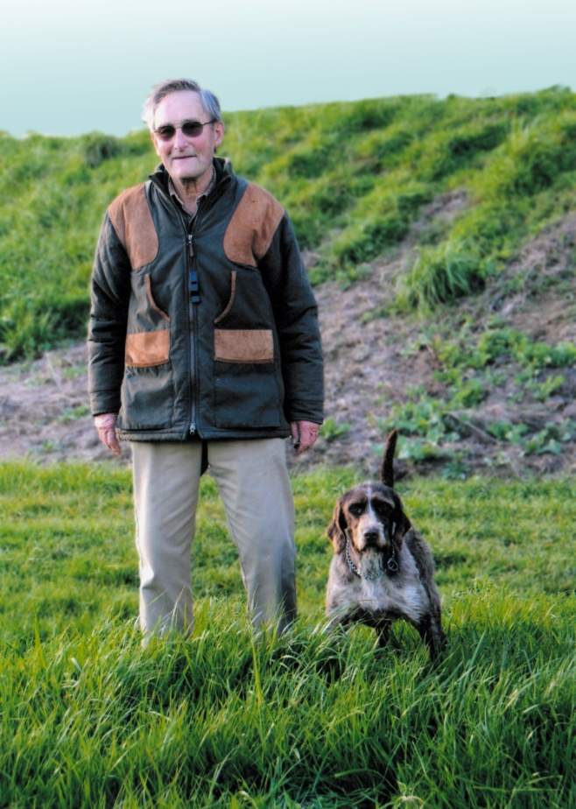
Figure 6 - Bodo with Winterhell's White Lie

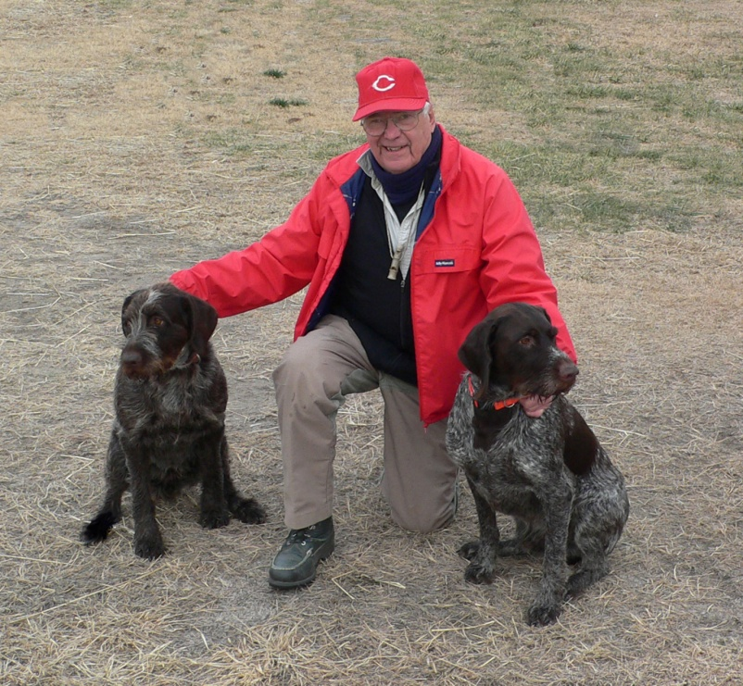
Figure 7 - Ed with Pepe (Ed’s left) and Missy (belonging to hunting friend)

